1st EU-RESOLVE Conference & Training School (Porto, June 16-18th, 2026)



EU-Resolution Biology Network
Guidelines for Oral Presentations, Flash Talks, and Posters



The following guidelines provide practical recommendations and technical requirements for preparing oral presentations, flash talks, and posters for the 1st EU-RESOLVE COST Conference & Training School.

Mandatory Branding & Logo Requirements
All presentation slides (Oral and Flash Talks) must correctly display the mandatory funding and network logos. Presenters must use the official versions provided in the template slide:
- EU-RESOLVE Logo: Available in Main or Horizontal Layouts (in blue or white background).
Main Layouts:



Horizontal Layouts:
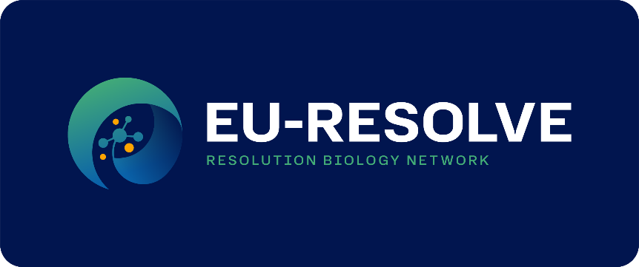



- COST Logo: Official European Cooperation in Science & Technology branding.



- European Union Logo: Official "Funded by the European Union" emblem.



Oral Presentation
Duration
- 10 min presentation + 5 min discussion
Preparation of your oral presentation
- We recommend preparing your presentation in a clean, professional format that prioritizes clarity and scientific content. Presentations must be prepared in Microsoft PowerPoint (.pptx), in 16:9 widescreen format and landscape orientation; other formats (including KeyNote) cannot be accommodated.
- Participants are encouraged to focus exclusively on scientific and educational content, avoiding any commercial promotion, sponsor branding, or identifiable conference templates, as well as any political or religious content.
- It is mandatory to include a disclosure slide at the beginning of the presentation, even if only to confirm that no conflicts of interest exist; this slide should remain visible long enough for the audience to read it clearly.
- Presenters are welcome to structure their slides as best suits their research narrative. To ensure the smooth running of the event, please strictly respect the presentation time allocated to your slot in the program, allowing sufficient time for discussion with the audience.
- Videos may be embedded or linked; however, compatibility should be tested in advance, and separate video files should be provided if required by the PowerPoint version used.
- Use high-contrast visuals and limit text per slide to ensure readability; figures and visuals should support the message rather than replace it.
- Make sure you deposit your presentation file prior to the session you are scheduled to give a talk, ideally at the start of the meeting during registration.
Flash Talks
Duration
- 5 min presentation
- Discussion will continue during the poster session.
Preparation of your flash talks:
- We recommend a concise and visually driven format designed to communicate a single key message effectively within a very limited timeframe.
- Presentations should consist of 3–5 slides, with minimal text and large, clear visuals that support the core finding rather than replicate it.
- Content should remain focused, direct, and scientifically oriented, highlighting only the essential message or main result.
- Timing should be carefully practiced in advance to ensure strict adherence to the allocated duration.
- The presentation should conclude with a clear invitation for discussion at the poster board, encouraging scientific exchange with the audience.

Poster presentation
Preparation of your poster presentation:
- Posters must be printed and displayed on the assigned poster board in the Poster Area. The required format is Portrait orientation (A0): 118.9 cm (height) x 84.1 cm (width).
- The layout should be clear and visually balanced, ensuring readability from at least 1 meter distance. Use color and include all relevant supporting material such as tables, figures, charts, and images.
- Poster must include the title, authors, affiliations, objectives, methods, results, and conclusions/outcomes of research. It is mandatory to include a disclosure statement.
- An email address of the presenting and/or corresponding author may be included at the bottom of the poster to facilitate scientific contact.
- QR codes, AR elements, and text key codes are permitted. If used, they must include the following disclaimer: “Copies of this poster obtained through QR, AR and/or text key codes are for personal use only and may not be reproduced without written permission of the authors.”
- Where commercial materials are presented, all relevant financial and non-financial interests should be appropriately disclosed.
- Make sure you place your poster at the respective desk (poster number will be followed) in the Poster Area prior to the Poster Session.

